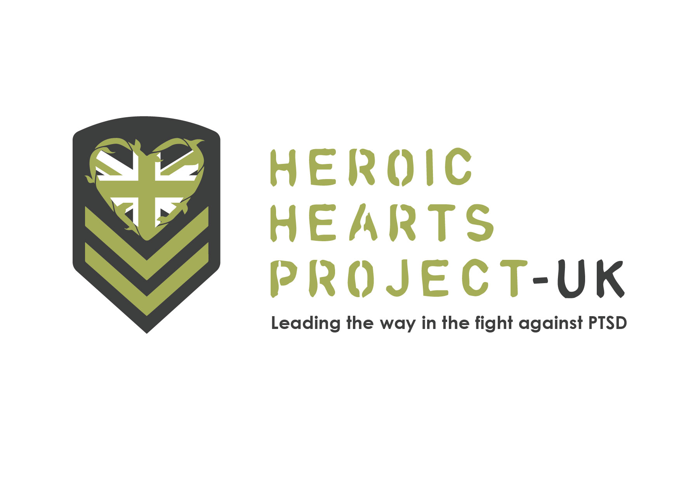

Veterans’ Registration
PLEASE PROVIDE DETAILED ANSWERS WHEN APPLICABLE - THIS WILL AFFECT OUR DECISION MAKING PROCESS.
* Required
1. Email address *
2. First Name *
3. Last Name *
4. Age *
5. Gender *
Mark only one (x)
Male
Female
6. Occupation *
7. City and County of Current Residence *
8. Phone Number *
9. Branch of Service *

10. Please provide your Military/Emergency Services Service Number and a description of your service. Please let us know about specific events that resulted in your current struggles. *
11. If the whole experience costs about £1,200 how much financial assistance would you need? *
Mark only one (x)
Complete
Partial
No Assistance Needed

12. Please describe your current financial situation and would you be interested in helping us
fundraise? *

13. Would you be willing to be interviewed on video or do you require anonymity? Please explain*
14. Do you have an valid passport? *
Mark only one (x)
Yes
No, but I am able to get one
No, and I am restricted from getting one
15. Do you have any medical conditions? Please describe them *
16. Do you have a personal or family history of heart condition or mental illness?
17. Are you currently taking any prescription drugs? If so, please inform us of the name(s) of the
drug(s) and dosage information*
18. Do You have any prior experience with entheogens? Which? *

19. Tell us more about your intentions and objectives. What do you hope to gain from this
treatment? Please be detailed *
20. Please describe your support network at home. Do you have a good network of family and friends that support your healing journey? If married, how does your significant other feel about this therapy? *
21. Have you tried other therapies to help you with these problems? Please briefly explain *
22. How much time are you able to take off to dedicate to this treatment? *
23. Anything else you would like us to know?
24. How did you hear about us? *

25. I understand that entheogens are not an approved therapy option within the UK and the facilitator, Heroic Hearts Project UK, does not and will not offer anything that can be considered medical advice. * Check all that apply.
Agree
27. If I find healing through this event, I will do what I can to help other veterans. * Check all that apply.
Agree
28. I confirm that the information given in this form is true, complete and accurate. *
Check all that apply.
Agree
For any specific questions, please email us at info@heroicheartsuk.com

